**Android Documentation**

**HR APP**

**Google / Huawei Services**

**Programming Lang:** Kotlin

**Technologies used:**

Google Play Services - Huawei Mobile Services

Developed by Project Manager

Mahmoud Ayman Mostafa Abd-ElRahman Hesham

1. Gradle Files (Dependencies and External Libs):

* There’s a file named: “dependcies.gradle” contains all the libraries and its versions separated into 2 sections (main-external).
* Main Section: that’s for main libs for every android project usually the libs supported by Google.
* External section: any other external libs to provide a specific feature.
* Target SDK is latest and min SDK is 17.
* Added Module in project called sweetdialoglib it’s an external lib but I’ve edited it with some modifications to meet our business here’s the [original link](https://github.com/pedant/sweet-alert-dialog).

1. 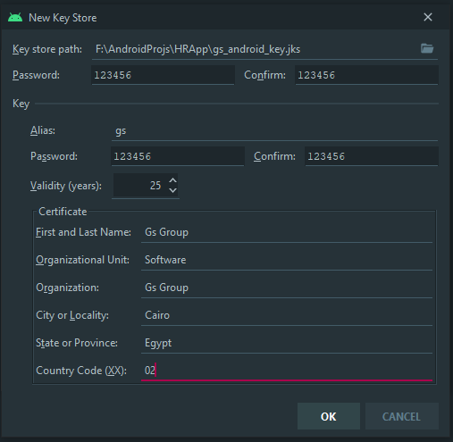Key store for publishing app: